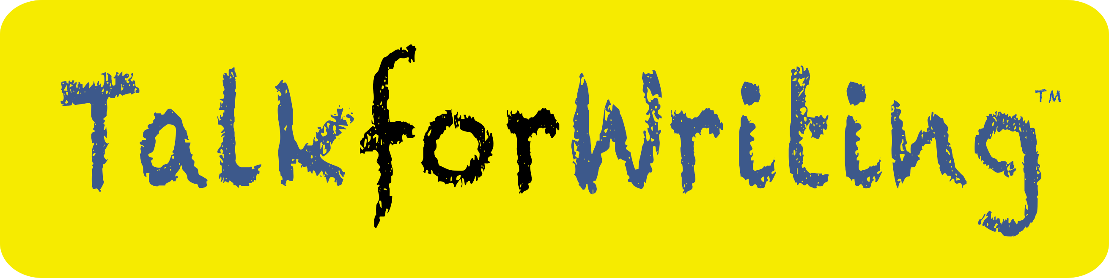
Talk for Writing consultant application form
for Scotland

Talk for Writing is looking for consultants who have the attributes listed below
General information
Successful candidates will work on behalf of Talk for Writing as independent self-employed consultants and will provide training to teachers. Consultants will receive training and resources from Talk for Writing. Bookings for Talk for Writing training are made with the consultant through the training page of the Talk for Writing website. The role will require a minimum commitment of at least two days a week.
Earnings
Consultants are paid for the training that they undertake by the schools they work with. The current fees can be found here: https://www.talk4writing.com/trainers. 20% of the fees received by the consultant are paid to Talk for Writing. Consultants are not salaried. Earnings are dependent on the amount of work that a consultant carries out.
Increasingly, Talk for Writing is moving towards a project model of training whereby schools commit to training over a period of two years rather than single one-off days. We have found this much more effective as a method to bring about whole-school change and improvement.

Applying
Please complete this form and return with a written application that addresses each of the suitability statements below and provides examples to back up your application. Please send your written application with the names and contact details of two referees and also a CV via email to Nick Batty at contact@talk4writing.com
Suitability criteria | Y/N
- Committed to the power of literacy to enhance the life chances of all children with a focus on those from disadvantaged backgrounds
- Presented successfully at whole-day conferences for large audiences (eg 50 - 100 people)
- Worked with clusters/networks of schools
- Run staff-training sessions in different schools
Led staff development sessions in a range of different school contexts
- Worked strategically with Senior Leadership Teams
- Modelled teaching in classrooms
- Worked alongside teachers on planning and assessment
- Read, understood and used the Creating Storytellers and Writers book and related online videos
- Prepared to stay away from home and travel around the country
- Able to commit to a minimum of two days a week.
- Able to attend termly training days in Birmingham and after-school online conferences.
- Possess a current DBS (CRB) check

Please tick to indicate that you are willing to commit to the following in Year 1:

Commitment in Year 1: Commit to completing the induction scheme involving: | Tick below
Visit at least one Talk for Writing training school within the first 6 months
Work with an experienced Talk for Writing trainer who will mentor you via phone or Zoom
Read all the core Talk for Writing texts and watching the related online content
Attend the three termly one-day TfW team days in Birmingham

All candidates are required to tick to show their agreement:

Candidates agree to: | Tick below
Commit to Talk for Writing as an exclusive trademarked and copyrighted activity
Agree to use the Talk for Writing financial agreement and diary management systems. (Currently 20% of Talk for Writing consultant’s earnings are paid back to Talk for Writing).

Application checklist:
- I have completed the form above with Y/N and tick boxes.
- I have completed and attached a written application which addresses how I fulfil each of the suitability criteria above.
- I have attached my CV.
- I have included the names and contact details of two referees (either on my written application or my CV).

Signed: …………………………………………………………..
Name: …………………………………………………………..
Date: …………………………………………………………..

